**QST Senior DevOps Engineer Assignment**

Version 1.1

## **Create a Virtual Machine on AWS**

1. I created a VM with minimal hardware specifications, 2GB RAM, 2 vCPU, 10GB disk space, and basic network connectivity.

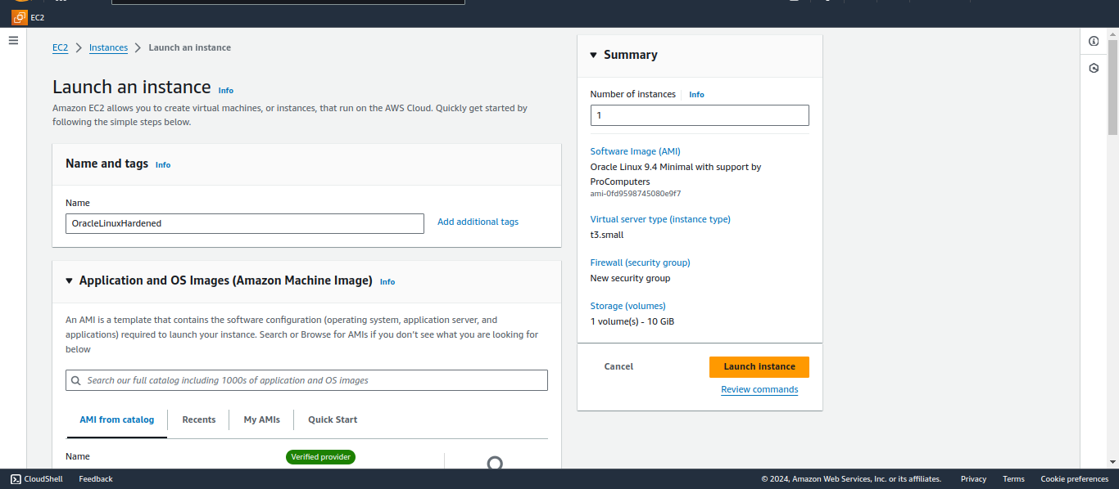

## **Deploy Latest Oracle Linux UEK, Harden it and Make it CIS Compliant**

1. I did minimal OS installation on the above VM.

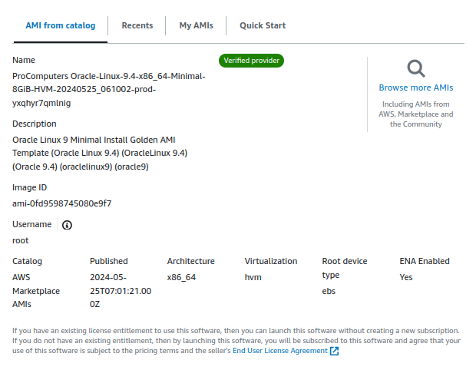

1. I hardened the VM and made it CIS compliant and attached the files for playbook summary, output of modprobe -c, and output of auditctl -l in the submission.

## **Create a Helm Chart to Run Prometheus Server in a Kubernetes Cluster**

1. I first created and installed the Helm Chart for Prometheus using:

helm install prometheus ./prometheus

1. I needed to adjust the scrape interval in Prometheus’ configuration. Initially, it was set to 15s, but I changed it to 10s by editing the configuration file:

prometheus.yml: |

global:

scrape_interval: 10s

1. After modifying the configuration file, I applied the changes by running:

helm upgrade prometheus ./prometheus

1. I checked the updated ConfigMap to ensure the changes:

kubectl get configmap prometheus-config -o yaml

1. I also verified the updated configuration inside the pod, it confirmed that the interval is set to 10s:

kubectl exec -it POD_NAME -- cat /etc/prometheus/prometheus.yml